FYP Controller Design:

- Design and control method inspired by modular synths and other patch cable compatible devices.

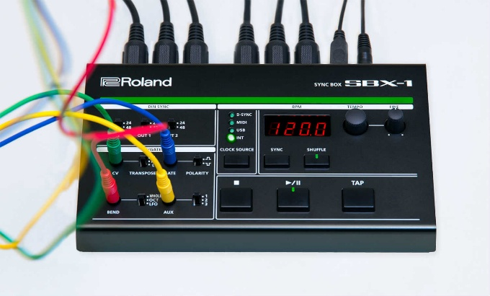

- Using real cables will accurately emulate the feel of such devices and help immerse the player. The knob analogue input (potentiometer) also adds to the overall theme of the controller.

Components:

Controller Components
Component | Quantity
Yellow LED | 3
Audio Jack | 7
Audio Cable | 3
Potentiometer | 1
Potentiometer knob (large) | 1
Large Red Button | 1
Raspberry Pi Pico W | 1
Jumper wires (soldering) | 13-20

